**Question 1:**

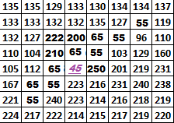



For the (8-by-8) image block given, It is required to do edge detection using the shown Sobel operators (assume the image has already been smoothed with a Gaussian filter):

1. Apply the x-gradient and y-gradient Sobel operators shown above to pixel [] 🡪 Find the values for $∆_{y} and ∆_{x}$
2. Using the values from (a), Calculate the **strength and orientation** of the gradient at that pixel. Does the orientation angle make sense according to the edge direction you see in the block?
3. In the Sobel edge detection we apply the following processes $∆_{x}=M_{x}^{Sobel}*\{g\left(x,y\right)*f\left(x,y\right)\}$ and ${∆_{y}=M}_{y}^{Sobel}*\{g\left(x,y\right)*f\left(x,y\right)\}$. Explain **what will be different** if you want to use the Canny edge detection (**Re-Write the equations in this case**).
4. Explain **Two reasons** why the Canny approach is better than the Sobel approach.

**Question 2:**

**(a)** For the 8-by-8 image above in Q1, apply the given Gaussian filter on pixel $f(5,4)=45$ and find the pixel’s new value. Has it been smoothed? Is this smoothing good or bad and why?



**(b)** Explain the main ideas of the **Bilateral Filter** and the **Non-local filter** approaches and show how they would avoid Blurring the edge in the above 8-by-8 block.

**(c)** Apply an Adaptive Median Filter on the above block centered at pixel $f(5,4)=45$**. Take initial window size=3 and (maximum) window size=5 (use only odd window size).**

**Find the new value for the pixel. Has it been blurred?**

**Question 3:**



1. **Explain using equations**: Why and How the Laplacian of Gaussian is used to detect blobs and how the Gaussian width “σ” determines the scale of the detected blob
2. Using the scale-space figure shown above explain **How** the difference-of-Gaussians (DoG) approach is used to find blobs in an image.
3. Explain How many blob scales can be detected using **Only the 2-Octaves** in the above structure.
4. 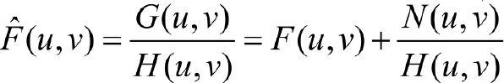

The above equation explains the inverse Filtering approach for image degradation removal.

Define each term in the equation showing what was the equation of the degraded image, what is $H\left(u,v\right), F\left(u,v\right)and N\left(u,v\right)$ and how can we obtain the restored image in the spatial domain.